Continuous LFP Client

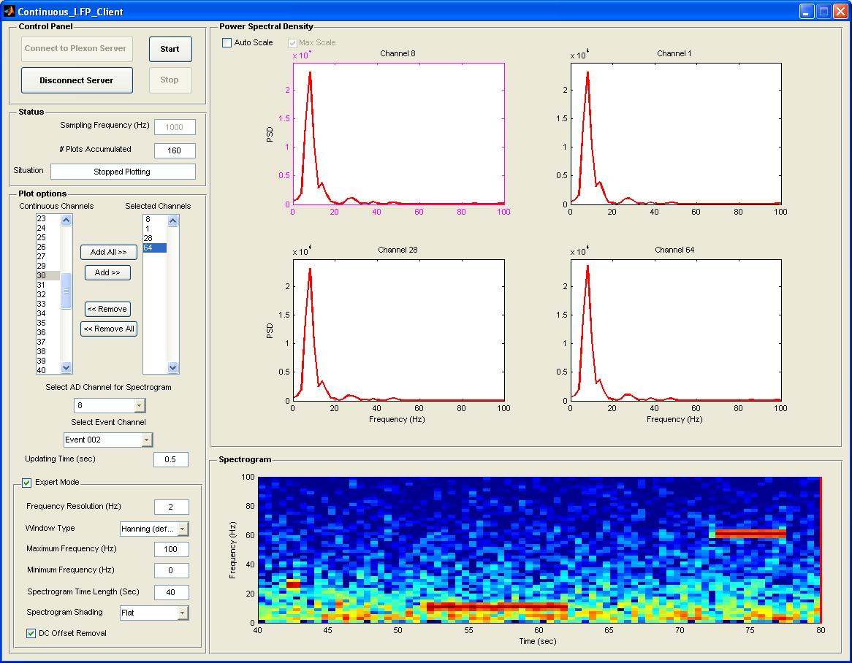

Control Panel

- Connect to Plexon Server
This push button makes a connection between the software and the Plexon server and gets the required information such as active AD channels, sampling frequency of each channel from the server.
- Disconnect Server
It disconnects the software from the server. When it is disconnected some parameters can be changed while the control panel buttons are disabled except the connection one.
- Start
Starts working based on the parameters set by the user.
- Stop
Stops the software and releases the locked options.

Status

- Sampling Frequency (Hz)
It reports the sampling rate of the selected AD channel.
- # Plots Accumulated
It shows the number of times which the plots have been drawn.
- Situation
It reports the current situation of the software e.g., connected, disconnected, and for which channel it is plotting.

Plot Options

- Continuous Channels
This box lists all the active AD channels in the Plexon server when the software gets connected to the server. The user can select some or all of them using the “Add/Add All” buttons to monitor the PSD of the selected channels in the power spectral density panel area. The maximum number of the channels which can be added is 16.
- Selected Channels
This list box will contain all the selected continuous channels to plot their PSD in the power spectral density panel. Some or all of the channels which has already been added to this box can be sent back to the continuous channels box by “Remove/Remove All” buttons. The list of all selected channels is automatically added/removed to/from the pop-up menu called “Select AD Channel for Spectrogram”.
- Select AD channel for Spectrogram
This pop-up menu will have the same list as the channels in the selected “channels list” box. The user can select one of the listed channels to monitor its spectrogram in the spectrogram panel.
- Select Event Channel
A list of all possible event channels is provided here. If the user is interested to monitor the time stamp of the events from a specific channel, it can be selected here before start.
- Updating Time (Sec)
It specifies the update time for the PSD plots and the spectrogram. The updating time also sets the “frequency resolution” as the inverse of the updating time quantity and also sets the “spectrogram time length” to 100 times the updating time value in the expert mode panel. It should be noted that the updating time cannot be necessarily satisfied since it depends to the CPU speed. However, the software manages the time to be synchronized.
- Expert Mode
The expert mode enables the user to change the parameters from their suggested values.
- Frequency Resolution (Hz)
The frequency resolution is set to the inverse of the window length (here updating time) used for Fourier transform. It tells the user about the frequency steps in the frequency domain for spectrogram/PSD. If it is needed to have higher resolution, the user can set it to a smaller value and the software will satisfy it by using longer window length with an overlap equal to the updating time.
- Window Type
Several window types are provided for the user for the spectral analysis.
- Maximum Frequency (Hz)
The maximum frequency information to be plotted in the vertical axis of the spectrogram and the horizontal axis of the PSD plots.
- Minimum Frequency (Hz)
The minimum frequency information to be displayed in the vertical axis of the spectrogram and the horizontal axis of the PSD plots.
- Spectrogram Time Length (Sec)
This option is used to specify the horizontal length of the spectrogram. So the software will display the spectrogram of the signal for this amount of time towards past.
- Spectrogram Shading
Shading for the spectrogram can be set to either “Flat” in order to display the colors corresponding to the exact values of the spectrogram matrix or “Interpolated” in order to interpolate for the elements of the spectrogram matrix to let the color display change smoother.
- DC Offset Removal
This option removes the DC of the signal by subtracting the average value of the temporal signal from the whole signal.

Power Spectral Density

This panel contains all the (maximum 16) PSD plots. The selected channel for the spectrogram between these plots is surrounded by a pink color. While the software is working and monitoring the spectral analysis on the selected AD channels the user can change the selected channel for the spectrogram by clicking on any of the PSD plots or changing the selection in the pop-up menu provided for this purpose. The new channel will be surrounded by pink color to show that the spectrogram is monitored for that channel.

- Auto Scale
When it is checked it lets the software to auto-scale the amplitude range for the PSD plots while when unchecked it will freeze the amplitude range to the last range for every PSD plot.
- Max Scale
The Max Scale check box is used to set the amplitude range in each updating time to the maximum between all the plots to help user easily compare between the different channels.
- Logarithmic
If it is checked the PSD amplitudes are going to be plotted in the dB unit.

Spectrogram

This panel contains the spectrogram of the selected AD channels based on the settings in “Plot Options” panel. If an event channel is selected the time at which the event form that channel is received will be displayed in spectrogram area by a red dashed line.

